ASSIGNMENT NO. 2-Study of XML and XSD
Name: Jatin Vishwakarma
Branch: Computer Science & Engineering (Un-Aided)
Batch: S-8
PRN: 255209004
Problem Statement 1
1. What is XML? Why is it called an Extensible Markup Language?
XML (Extensible Markup Language) is a markup language used to store and transport data in a structured and readable format. It is called extensible because users can define their own custom tags according to application needs, unlike HTML which has predefined tags.
2. Difference between Well-Formed and Valid XML + Structure
Well-Formed XML
- Follows XML syntax rules
- Proper opening and closing tags
- Correct nesting
Valid XML
- Well-formed and Follows rules defined in DTD or XSD.

Basic XML Structure Example
<?xml version="1.0" encoding="UTF-8"?>
<student>
<name>Jatin</name>
<branch>CSE</branch>
</student>

3. Difference between XML and HTML
XML | HTML
Used to store data | Used to display data
User-defined tags | Predefined tags
Strict syntax | Lenient syntax
Platform independent | Browser dependent
XML is preferred for data storage because it is structured, flexible, and platform independent.
4. What is XSD? Why preferred over DTD?
XSD (XML Schema Definition) defines structure, data types, and constraints of an XML document.
Why XSD over DTD
- Supports data types
- Written in XML
- Better validation
- Namespace support
Roles
- xsd:schema → Root of schema
- xsd:element → Defines elements
- xsd:complexType → Defines nested elements
5. Difference between simpleType and complexType
simpleType | complexType
No child elements | Can contain child elements
Used for values | Used for structures

Example
<xsd:simpleType name="yearType">
<xsd:restriction base="xsd:string">
<xsd:enumeration value="Second"/>
<xsd:enumeration value="Third"/>
<xsd:enumeration value="Fourth"/>
</xsd:restriction>
</xsd:simpleType>

6. Linking XML with XSD & Role of xsi
XML is linked to XSD using:
xsi:noNamespaceSchemaLocation="student.xsd"
xsi (XML Schema Instance) tells the parser where the schema is located.

7. How XSD enforces data constraints
Example 1: Restrict phone length
<xsd:restriction base="xsd:string">
<xsd:length value="10"/>
</xsd:restriction>
Example 2: Allowed year values
<xsd:enumeration value="Second"/>

8. minOccurs and maxOccurs
- minOccurs → Minimum occurrences
- maxOccurs → Maximum occurrences
They control how many times an element can appear during validation.

9. XML well-formed but not valid – Reasons
- Missing XSD
- Data type mismatch
- Invalid value (not allowed by schema)
- Missing mandatory element

10. Real-world usage & XML vs JSON
Uses
- Web services (SOAP)
- Configuration files
- Banking systems
- Data exchange
XML | JSON
Verbose | Lightweight
Schema based | Faster
Used in enterprise apps | Used in APIs

Problem Statement 2

Task 1: student.xml
<?xml version="1.0" encoding="UTF-8"?>
<students xmlns:xsi="http://www.w3.org/2001/XMLSchema-instance"
xsi:noNamespaceSchemaLocation="student.xsd">

<student>
<studentId>101</studentId>
<name>Jatin</name>
<year>Second</year>
<branch>CSE</branch>
<email>jatin@gmail.com</email>
<phone>9876543210</phone>
</student>

<student>
<studentId>102</studentId>
<name>Rahul Patil</name>
<year>Third</year>
<branch>CSE</branch>
<email>rahul@gmail.com</email>
<phone>9123456789</phone>
</student>

</students>

Task 2: student.xsd
<?xml version="1.0" encoding="UTF-8"?>
<xsd:schema xmlns:xsd="http://www.w3.org/2001/XMLSchema">

<xsd:element name="students">
<xsd:complexType>
<xsd:sequence>
<xsd:element name="student" maxOccurs="unbounded">
<xsd:complexType>
<xsd:sequence>

<xsd:element name="studentId" type="xsd:integer"/>

<xsd:element name="name" type="xsd:string"/>

<xsd:element name="year">
<xsd:simpleType>
<xsd:restriction base="xsd:string">
<xsd:enumeration value="Second"/>
<xsd:enumeration value="Third"/>
<xsd:enumeration value="Fourth"/>
</xsd:restriction>
</xsd:simpleType>
</xsd:element>

<xsd:element name="branch" type="xsd:string"/>

<xsd:element name="email" type="xsd:string"/>

<xsd:element name="phone">
<xsd:simpleType>
<xsd:restriction base="xsd:string">
<xsd:length value="10"/>
</xsd:restriction>
</xsd:simpleType>
</xsd:element>

</xsd:sequence>
</xsd:complexType>
</xsd:element>
</xsd:sequence>
</xsd:complexType>
</xsd:element>

</xsd:schema>

Task 3: Linking XML with XSD
Linked using:
xsi:noNamespaceSchemaLocation="student.xsd"

Task 4: Validation
The XML file was validated successfully using VS Code XML extension, and no errors were found.

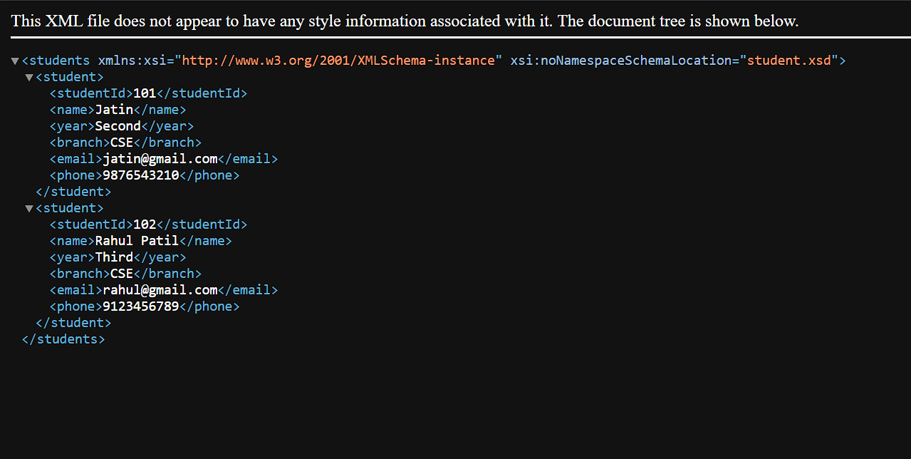
Outputs:

